***ENVY***

**Competitive Financial App**



**Contents**

Introduction………………………………………………………………………………………3

Summary………………………………………………………………………………………...4

Lesson Learned…………………………………………………………………………………5

Conclusion……………………………………………………………………………………….6

Supplemental 1: All Scripts, views, and queries------------------------------------------------------

User Defined Types……………………………………………………………………..7

List of Tables……………………………………………………………………………..8

List of Views and related queries………………………………………………………9

List of functions, procedures and triggers…………………………………………..10

Supplemental 2:Project Design---------------------------------------------------------------------------

ER - Diagram…………………………………………………………………………..11

Data Dictionary………………………………………………………………………...12

Normalization…..………………………………………………………………………17

***Introduction***

* **Company Name:** Half-Stack Devs
* **App Name:** Envy
* **Members:**
  + *Arvin Tahernia*
  + *Bruce Dascalescu*

It can be difficult to manage your finances without some personal accountability, but even then it can be easy to get carried away with spending. So why not have other people hold you accountable too? Our application merges concepts of social media and banking into one package. With this system, you can track your spending and income all while competing with your friends on who has the greatest personal growth. No sensitive information would be shared to the public of course. Instead, your assets will be calculated and shown on your profile on a weekly basis. The idea is to give you just a bit of extra pressure in this dog eat dog world.

No sensitive information will be shared such as income, amount in the bank, assets, etc. The only thing that your friends will be able to see is your information that you upload (e.g occupation, bio) and weekly score. The assets and financial information are inputted by the user anytime they wish. In a sophisticated system, we would ideally be connected to the user's bank account and request verification of assets (e.g house, cars) to keep track of everything dynamically but as that is out of our scope we will be doing it this way. Users will also be able to delete their account and dump info that is connected to them as that info is their property.

***Summary***

The app will allow you to create an account and profile where you will be able to create your biography, set your current job title, education level, and goals. You will also be able to post on a home feed where you and your friends can upload text (like facebook). Every week the app will update your profile based on your income and current assets, showing a rank going from:

* + Coal: score of 0 - 149
  + Bronze: score of 150 - 249
  + Bronze +: 250 - 349
  + Silver: 350 - 449
  + Silver +: 450 - 549
  + Gold: 550 - 649
  + Gold+: 650 - 749
  + Diamond: 750 +

***Lesson Learned***

What we have learned from this lesson is how to utilize the use of triggers, tables, and views for creating a visual for our program. We first use our parent table, “envy_accounts” to enter and store information that will be used for the login script. The primary key “username” is the unique field that will be used for identifying each field. Each user will create usernames, passwords, regions, and a hint to remember their passwords. We utilize our other tables to store more information about their financial status and use that information to create an algorithm to show “ranks” in our leaderboard table.

Using the techniques we learned in our class modules about data manipulation and control statements helped us create this program and we utilize as much as we can from what we learn this semester. This application will be used to create an account, store information in that profile and share a calculation of assets without showing any sensitive information that the user inserted in their financials table. Because this application is strict about safety and privacy, it is easy to remove any information you entered and dump that info that is connected to that as that info is their property.

***Conclusion***

This project seemed very daunting at first, but once we started doing more quality improvement and adding more tables to store information of our clients, it became much easier to implement a ranking system to our leaderboard. The program itself turned out better than expected and we tried to implement everything we learned this semester into our project. Utilizing Data manipulation languages to include many commands to permit the users to manipulate the data in the database, helped us create a great interface that is simple to use and pleasing to the eye. Since we wanted our program to be a safe place for data to be stored, we implemented a drop program to drop any information a user did not want in the program anymore. Adding this increases security and gives the user privileges to manage their data. Our application merges concepts of social media and banking into one package.

With this system and added security , you can track your spending and income all while competing with your friends on who has the greatest personal growth. No sensitive information would be shared to the public of course. Instead, your assets will be calculated and shown on your profile on a weekly basis. We had a very tough time finishing this with the information we had, but we did a lot of independent research to get our program correctly working. This program shows our mastery in trying to implement all of our studies in the application.

***Supplemental 1 - Defined Data Types***

We used about 3 different types of data types, Numeric, Varchar, and text. These data types we used are important to store information and we use these 3 data types because it was the simplest we could make the program without any issues in the code.

***Supplemental 1- Tables***

There are 9 tables we used in this project;

* Envy_accounts
* Envy_account_info
* Envy_content
* Envy_friends
* Envy_guilds
* Envy_homefeed
* Envy_guildfeed
* Envy_financials
* Envy_leaderboard

***Supplemental 1 - List of Views and related queries***

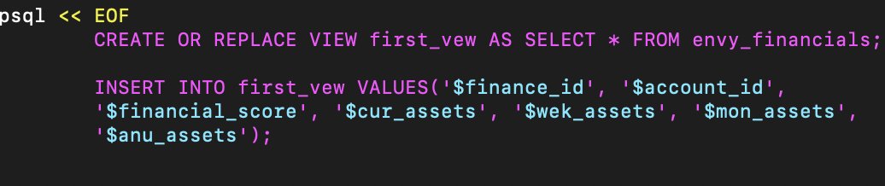

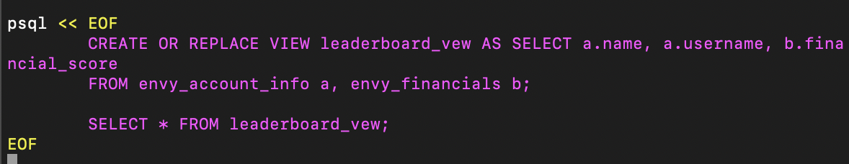

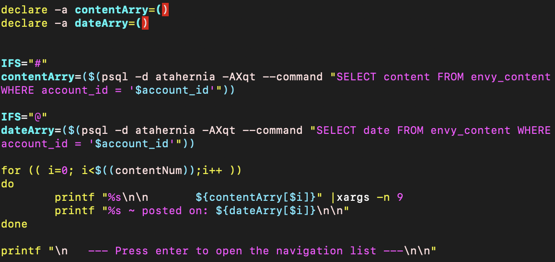

***Supplemental 1- List of functions, procedures and triggers***

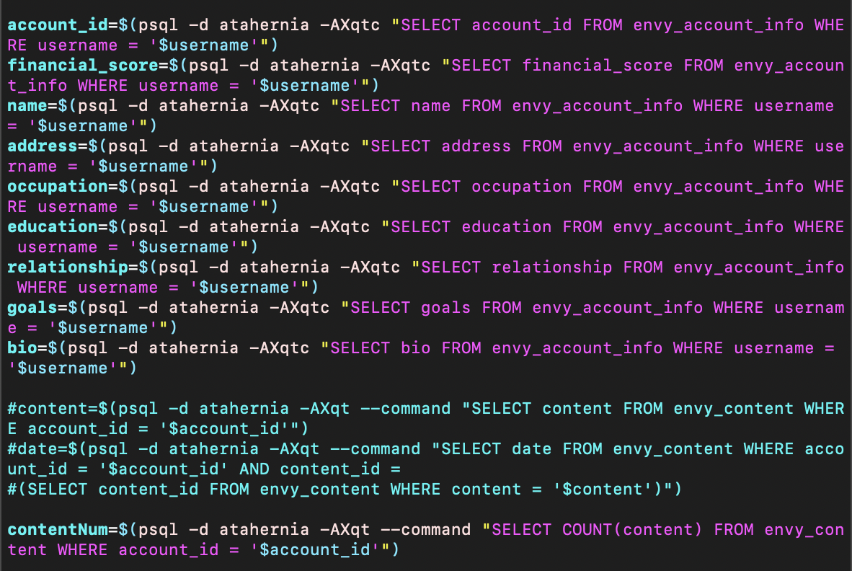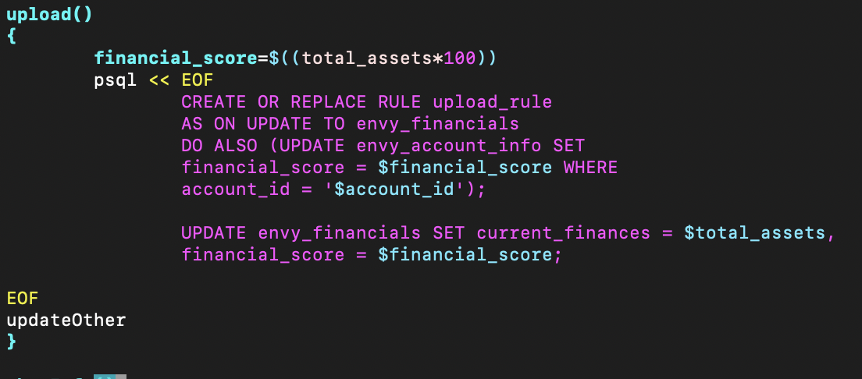



***Supplemental 2- ER Diagram***

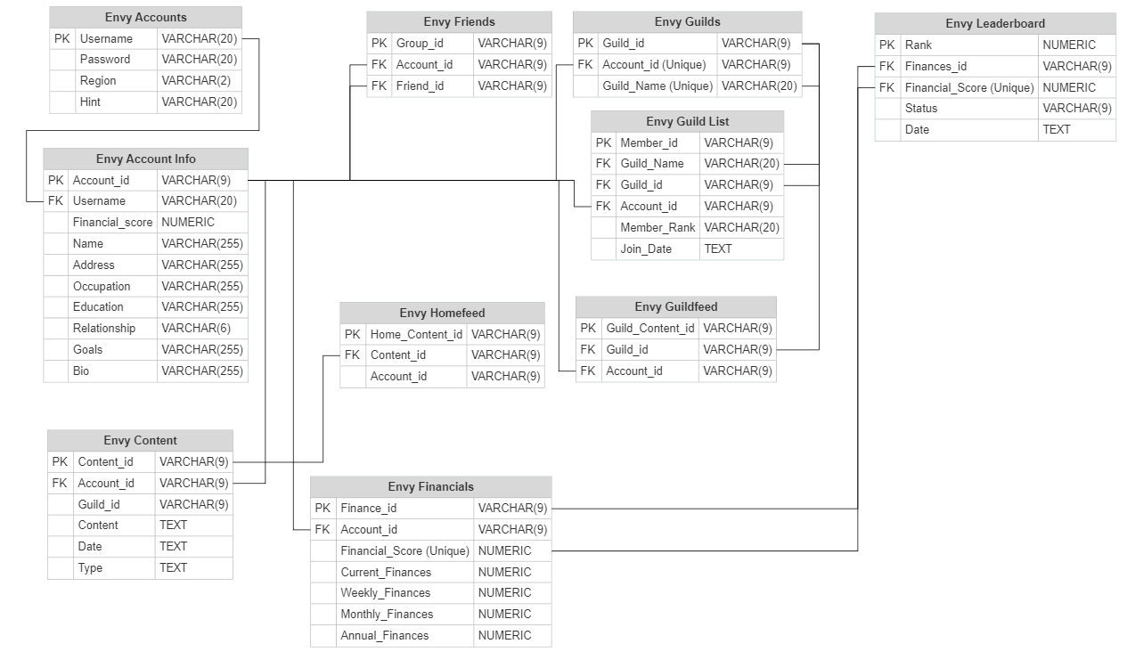

***Supplemental - Data Dictionary***

**Envy_accounts Table**

| **P/F** | **Field Name** | **Caption** | **Data Type** | **Field Size** | **Notes** |
| --- | --- | --- | --- | --- | --- |
| P | Username | You will be using this to sign into your account | VARCHAR | 20 | Primary Key |
|  | Password | Password for said account for username | VARCHAR | 20 |  |
|  | Region | Initials of State you are residing in ( Example - California = CA) | VARCHAR | 2 |  |
|  | Hint | Hint for Password | VARCHAR | 20 |  |

**Envy_Account_Info Table**

| **P/F** | **Field Name** | **Caption** | **Data Type** | **Field Size** | **Notes** |
| --- | --- | --- | --- | --- | --- |
| P | Account_id | Unique Account ID | VARCHAR | 9 | Primary Key |
| F | Username |  | VARCHAR | 20 | Foreign Key - References to Username in Envy_accounts table |
|  | Financial_score | Score of your Financials | NUMERIC |  |  |
|  | Name |  | VARCHAR | 255 |  |
|  | Address | Where you live | VARCHAR | 255 |  |
|  | Occupation | Career | VARCHAR | 255 |  |
|  | Education | Educational status | VARCHAR | 255 |  |
|  | Relationship | Single / Married | VARCHAR | 6 |  |
|  | Goals | About what Goal you’d like to set for your Financials | VARCHAR | 255 |  |
|  | Bio | About yourself | VARCHAR | 255 |  |

**Envy_friends Table**

| **P/F** | **Field Name** | **Caption** | **Data Type** | **Field Size** | **Notes** |
| --- | --- | --- | --- | --- | --- |
| P | Group_id | Unique Group ID | VARCHAR | 9 | Primary Key |
| F | Account_id | Unique Account ID | VARCHAR | 9 | Foreign Key - References to Account_id in envy_account_info table |
| F | Friend_id | Unique Friend ID | VARCHAR | 9 | Foreign Key - References to Account_id envy_account_info table |

**Envy_guilds Table**

| **P/F** | **Field Name** | **Caption** | **Data Type** | **Field Size** | **Notes** |
| --- | --- | --- | --- | --- | --- |
| P | Guild_id |  | VARCHAR | 9 | Primary Key |
| F | Account_id | Unique Account ID | VARCHAR | 9 | Foreign Key - References to Account_id in envy_account_info table |
|  | Guild_name | Custom guild name | VARCHAR | 20 |  |

**Envy_ guild_list**

| **P/F** | **Field Name** | **Caption** | **Data Type** | **Field Size** | **Notes** |
| --- | --- | --- | --- | --- | --- |
| P | Member_id |  | VARCHAR | 9 | Primary Key |
| F | Guild_name |  | VARCHAR | 20 | Foreign Key - References to guild_name in envy_guilds table |
| F | Guild_id |  | VARCHAR | 9 | Foreign Key - References to guild_id in envy_guilds table |
| F | Account_id |  | VARCHAR | 9 | Foreign Key - References to account_id in envy_account_info table |
|  | Member_Rank | The guild member’s rank compared to other members | VARCHAR | 20 |  |
|  | Join_date | The date you joined the guild | TEXT |  |  |

**Envy_content Table**

| **P/F** | **Field Name** | **Caption** | **Data Type** | **Field Size** | **Notes** |
| --- | --- | --- | --- | --- | --- |
| P | Content_id |  | VARCHAR | 9 | Primary Key |
| F | Account_id |  | VARCHAR | 9 | Foreign Key - References to account_id in envy_account_info table |
|  | Guild_id |  | VARCHAR | 9 |  |
|  | Content |  | TEXT |  |  |
|  | Date |  | TEXT |  |  |
|  | Type |  | TEXT |  |  |

**Envy_homefeed Table**

| **P/F** | **Field Name** | **Caption** | **Data Type** | **Field Size** | **Notes** |
| --- | --- | --- | --- | --- | --- |
| P | Home_content_id |  | VARCHAR | 9 | Primary Key |
| F | Content_id |  | VARCHAR | 9 | Foreign Key - References to content_id in envy_content table |
|  | Account_id |  | VARCHAR | 9 |  |

**Envy_guildfeed Table**

| **P/F** | **Field Name** | **Caption** | **Data Type** | **Field Size** | **Notes** |
| --- | --- | --- | --- | --- | --- |
| P | Guild_content_id |  | VARCHAR | 9 | Primary Key |
| F | Guild_id |  | VARCHAR | 9 | Foreign Key - References to guild_id in envy_guilds |
| F | Account_id |  | VARCHAR | 9 | Foreign Key - References to account_id in envy_account_info table |

**Envy_financials Table**

| **P/F** | **Field Name** | **Caption** | **Data Type** | **Field Size** | **Notes** |
| --- | --- | --- | --- | --- | --- |
| P | Finance_id |  | VARCHAR | 9 |  |
| F | Account_id |  | VARCHAR | 9 | Foreign Key - References to account_id in envy_content table |
|  | Financial_score |  | NUMERIC |  |  |
|  | Current_finances |  | NUMERIC |  |  |
|  | Weekly_finances |  | NUMERIC |  |  |
|  | Monthly_finances |  | NUMERIC |  |  |
|  | Annual_finances |  | NUMERIC |  |  |

**Envy_leaderboard**

| **P/F** | **Field Name** | **Caption** | **Data Type** | **Field Size** | **Notes** |
| --- | --- | --- | --- | --- | --- |
| P | Rank |  | NUMERIC |  |  |
| F | Finances_id |  | VARCHAR | 9 | Foreign Key - References to finance_id in envy_financials |
| F | Finanical_score | Unique score of your overall financial score | NUMERIC |  | Foreign Key - References to financial_score in envy_financials |
|  | Status |  | VARCHAR | 9 |  |
|  | Date |  | TEXT |  |  |

***Supplemental 2 - Database* Normalization**

| **Raw Data** | **Sort Data** | **Remove Duplicates** | **Renamed to Understandable** | **Tables** |
| --- | --- | --- | --- | --- |
| username*  password  region  hint  account_id*  username  financial_score  name  address  occupation  education  relationship  goals  group_id*  account_id  friend_id  guild_id*  account_id  guild_name  member_id*  guild_name  guild_id  account_id  member_rank  join_date  content_id*  account_id  guild_id  content  date  type  home_content_id*  content_id  account_id  guild_content_id*  guild_id  account_id  finance_id*  account_id  financial_score  current_finances  weekly_finances  monthly_finances  annual_finances | username*  password  region  hint  account_id*  username  financial_score  name  address  occupation  education  relationship  goals  group_id*  account_id  friend_id  guild_id*  account_id  guild_name  member_id*  guild_name  guild_id  account_id  member_rank  join_date  content_id*  account_id  guild_id  content  date  type  home_content_id*  content_id  account_id  guild_content_id*  guild_id  account_id  finance_id*  account_id  financial_score  current_finances  weekly_finances  monthly_finances  annual_finances | username*  password  region  hint  account_id*  financial_score  name  address  occupation  education  relationship  goals  group_id*  friend_id  guild_id*  guild_name  member_id*  member_rank  join_date  content_id*  content  date  type  home_content_id*  guild_content_id*  finance_id*  current_finances  weekly_finances  monthly_finances  annual_finances | username*  password  region  hint  account_id*  username  financial_score*  name  address  occupation  education  relationship  goals  group_id*  account_id*  friend_id  guild_id*  account_id  guild_name*  member_id*  guild_name*  guild_id*  account_id*  member_rank  join_date  content_id*  account_id*  guild_id*  content  date  type  home_content_id*  content_id  account_id  guild_content_id*  guild_id  account_id  finance_id*  account_id  financial_score  current_finances  weekly_finances  monthly_finances  annual_finances | **envy_accounts**  **envy_account_info**  **envy_friends**  **envy_guild**  **envy_guild_list**  **envy_content**  **envy_homefeed**  **envy_guildfeed**  **envy_financials** |